# Locum My Account (Profile)

## Main

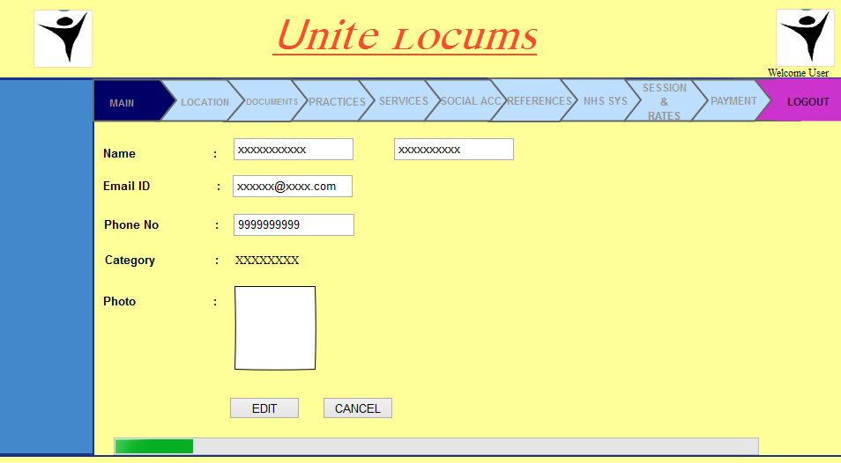

* Improve UI – tabs to be mobile friendly
* Display& CaptureGPGMC Number if GP Locum
* Display & Capture Dentist Number (GDC) if Dentist
* Display & Capture Nurse NMC Number / GMC / HCPC / Other if Nurse
* Photo upload / edit / delete – SECURITY (Privacy), size limit, minimum resolution
* Work Phone # / Work Mobile # - capture which is preferred for calling
* Phone # - UK format support
* “Do you operate as a Limited Company” – checkbox + Company Number
* Capture NI number
* Summary of Profile – text area
* Capture Gender – Radio button group – Male – Female – Other
* Qualifications – multi select listbox - CATALOGUE
* Language Proficiency – English – Levels (radio buttons)
* Any other languages known? – Multi select listbox – CATALOGUE
* Capture “Are you British Citizen?” If no capture eligibility to work in UK is mandatory

## Location

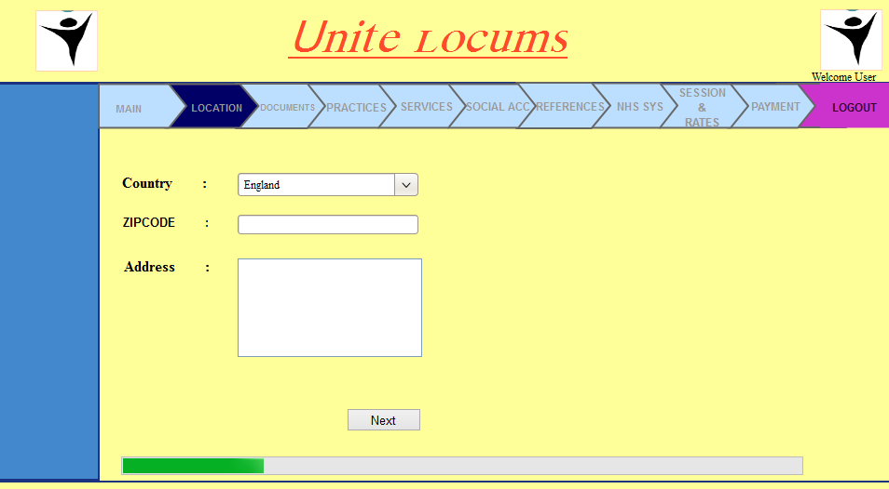

* Change country to United Kingdom
* Investigate Google API for Country Code list - CATALOGUE
* Investigate Quick Address / Royal Mail Postal Address service
* Address should be separate fields
  + House Name/Number
  + Address Line 1 – 3
  + Town
  + City
  + County
  + Post Code
* Capture “Is this Business (Billing) Address”
* If no then capture Billing address separately

## Documents

The list of documents required will be by Category, when a category is known system will automatically list the documents required for that Category with the mandatory ones clearly highlighted. For optional documents, User will check the “checkbox” and system will allow upload of that document type.

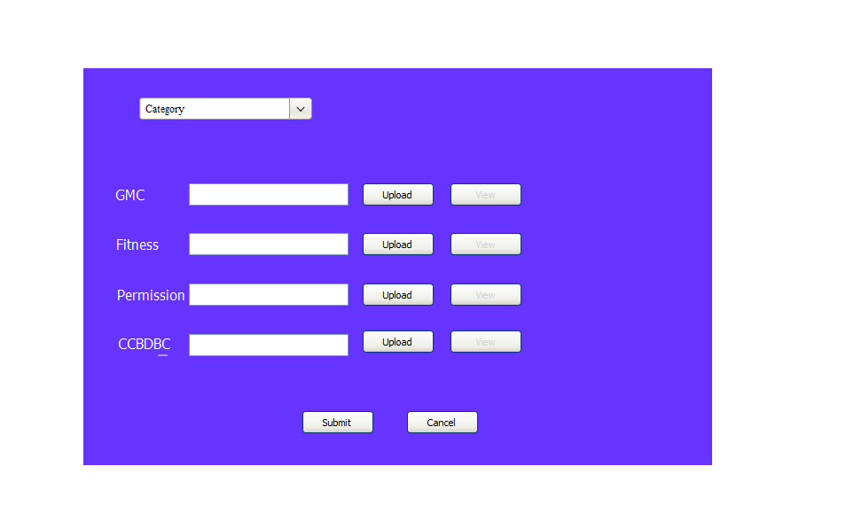

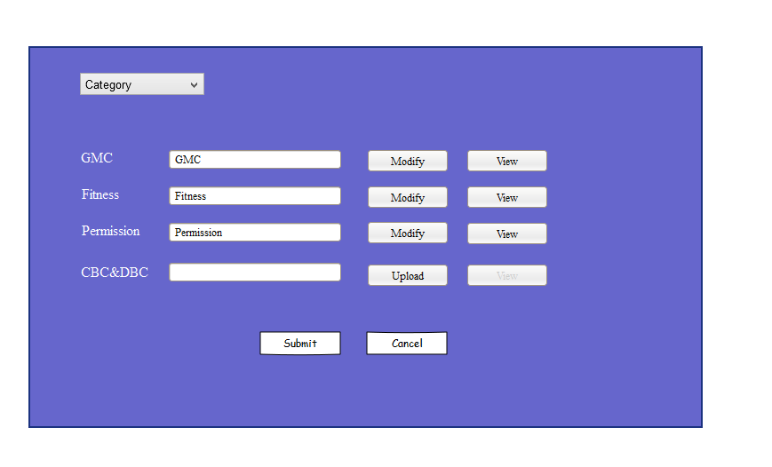

### GPs

* GMC Registration Certificate
* Latest Performer List Report – current year
* Indemnity Insurance Certificate (what amount?)
* Eligibility to work in UK? Passport (if British)else Work Permit/EEA card/etc.?
* Current DBS
* Latest CV (Word or PDF)
* Identification – Passport / Driving License

### Dentist

* GDC Registration Certificate
* Performer List Report
* Indemnity Insurance Certificate
* Eligibility to work in UK? Passport / Work Permit / etc?
* Current DBS
* Latest CV (Word or Pdf)
* Identification – Passport / Driving License

### Nurses (Dental / Non-Dental)

* NMC Registration Certificate
* Eligibility to work in UK? Passport / EEA card/ Work Permit / etc?
* Current DBS (within 36 months)
* Latest CV (Word or PDF)
* Identification – Passport / Driving License
* Qualifications Certificate
* Training Certificate

Email action on each document (where document exists) , this feature will allow user to email that document to interested parties

## Health Declaration

Add a new tab for Health Declaration

On this tab capture below along with proof of each

Diphtheria, Tetanus, Polio, Serology / Vaccination Report Cards: Mumps, Varicella - evidence of 2 vaccinations, Hepatitis B & Hepatitis Booster, Tuberculosis & BCG

Disclaimer at footer - CONTENT

### Preferred Practices

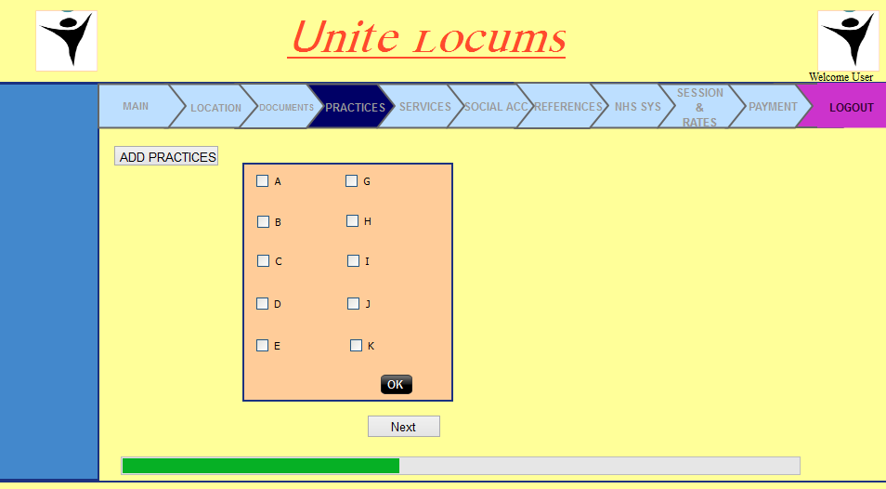

* UI not in line with Business requirements
* Add practices should open a window to capture the Practice from a list of Practices
* User should be allowed to delete Practices on the screen
* Practice details on grid show Name, Contact Person, Contact Email, Contact Number

### Services

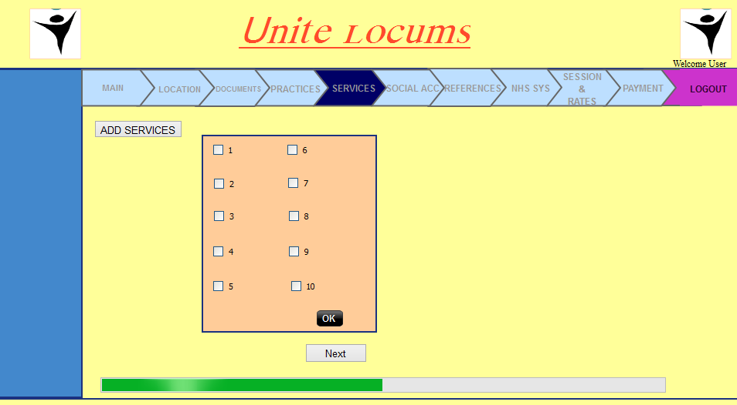

* Services to be considered after PoC
* Basic package services will be mandatory
* Enterprise package services will be optional

Social Account

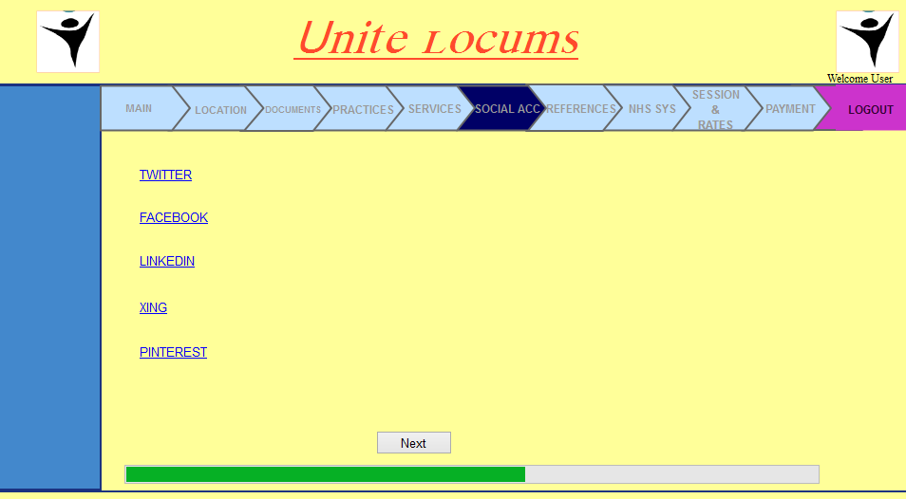

* Add icon for each social
* Have a textbox to capture URls for each social account
* They are all optional
* Add Skype id

References

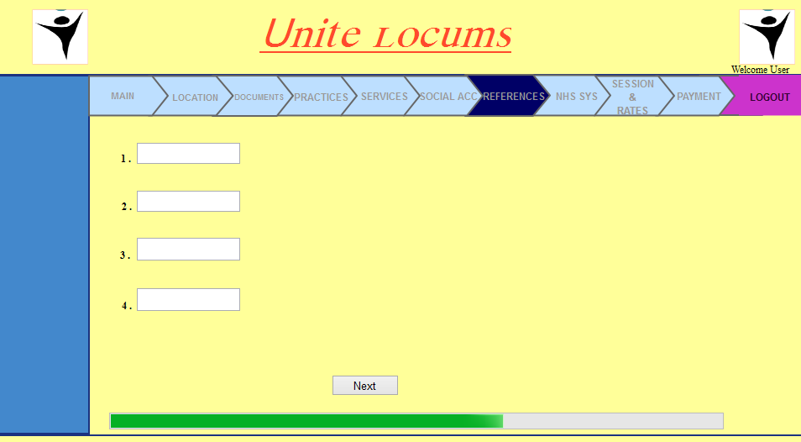

* Add button to “Add Reference”, this will open a window to capture Reference detail. Once reference is added it should appear on the list in above screen
* Against each reference in the list there should be means to Edit/View/Delete
* Minimum 3
* Maximum is unlimited but only show latest 5 , rest all show them under archived

NHS Systems Knowledge

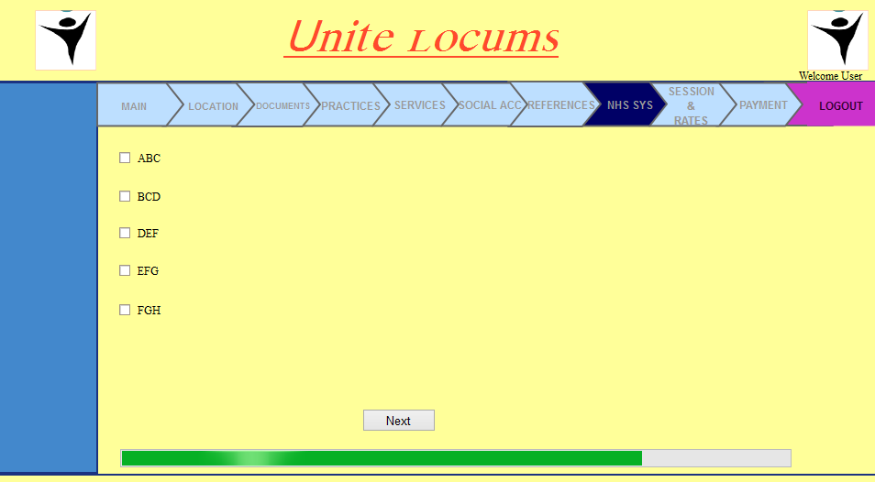

* List should come from a system catalogue
* User will “tick” against NHS system they are familiar with
* All optional

Session & Rates

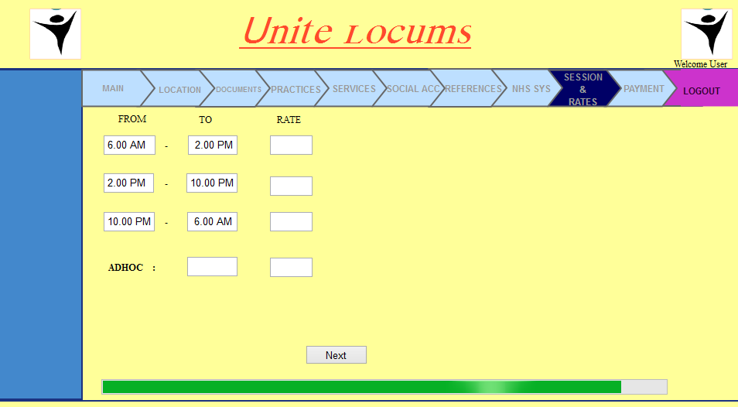

“Day rate (fixed from 9am to 6pm)” – capture this value if aaplicable

“Out of Office (fixed after 6pm)” – capture this

Flexible entries with time selected using dropdowns with clear boundaries (validate for no over lapping period)

Initial support for GBP / Euro / Dollar - dropdown on currency, default as per Country location